
513

ADL系列导轨式电能表
ADL Series DIN-Rail Mounted Electric Energy Meter

安装使用说明书V1.0
Installation and Operation Instructions V1.0

安科瑞电气股份有限公司
Acrel Electric Co., Ltd.
申明
Statement
版权所有，未经本公司之书面许可，此手册中任何段落、章节内容均不得摘抄、拷贝或以任何形式复制、传播，否则一切后果由违者自负。
All rights reserved. Without the written permission of the Company, any paragraph or section of this manual shall not be extracted, copied or reproduced or distributed in any form. Otherwise, all consequences shall be borne by the violator.
本公司保留一切法律权利。
The Company reserves all legal rights.

本公司保留对本手册所描述之产品规格进行修改的权利，恕不另行通知。订货前，请垂询当地代理商以获悉本产品的当前规格。
Our Company reserves the right to modify the product specifications described in this manual without further notice. Please consult your local agent for the current specifications of this product before placing an order.
修订记录：
日期 | 更改前 | 更改后 | 内容
2023.0530 |  | V1.0 | 初始版本

目 录
Contents
1 概述 1
1 Overview 1
2 型号说明 1
2 Description of Model 1
3 功能列表 1
3 List of Functions 1
4 技术参数 2
4 Technical Parameters 2
5 外形尺寸 4
5 Overall Dimensions 4
6 接线与安装 4
6 Connection and Installation 4
6.1电压电流接线示意图 4
6.1 Schematic Diagram of Voltage and Current Connection 4
6.2 功能性端子 6
6.2 Functional Terminal 6
7 主要功能特点 6
7 Main Functional Features 6
7.1 测量功能 6
7.1 Measurement Function 6
7.2计量功能 7
7.2 Metering Function 7
8操作与显示 7
8 Operation and Display 7
8.1按键功能说明 7
8.1 Key Function Description 7
8.2显示界面 8
8.2 Display Interface 8
8.3编程界面 10
8.3 Programming Interface 10
8.4可设置数据项 11
8.4 Settable Data Items 11
9 通信说明 11
9 Communication Instructions 11
9.1 地址表 12
9.1 Address Table 12

1 概述

1 Overview
ADL系列导轨式多功能电能表，是主要针对于光伏并网系统、微逆系统、储能系统、交流耦合系统等新能源发电系统而设计的一款智能仪表，产品具有精度高、体积小、响应速度快、安装方便等优点。具有对电力参数进行采样计量和监测，逆变器或者能量管理系统（EMS）与之进行通讯，根据实时功率及累计电能实现防逆流、调节发电量、电池充放电等功能，可双向计量，实现户用分布式光伏能量管理。
ADL series DIN-rail mounted multifunctional electric energy meter is an intelligent instrument mainly designed for new energy power generation systems such as photovoltaic grid-connected system, micro inverter system, energy storage system, AC coupling system, etc. The product has the advantages of high precision, small volume, high respondent speed and convenient installation. The product has the features of sampling, metering and monitoring power parameters, communicating with an inverter or an energy management system (EMS), realizing the functions of preventing reverse flow, regulating power generation, charging and discharging batteries according to real-time power and accumulated electric energy, and realizing bidirectional metering and household distributed photovoltaic energy management.

2 型号说明

2 Description of Model
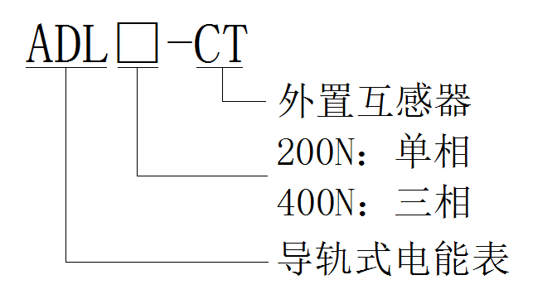
外置互感器
External current transformer
200N：单相
200N: Single-phase
400N：三相
400N: Three-phase
导轨式电能表
Guide rail-type electric energy meter

3 功能列表

3 List of Functions
表1 功能说明列表
Table 1 List of Function Descriptions
功能  Function | 功能说明  Descriptions | ADL200N-CT | ADL400N-CT
电能计量  Electric energy metering | 有功电能计量（正、反向）  Active energy metering (forward and reverse) | ■ | ■
电能计量  Electric energy metering | 无功电能计量（正、反向）  Reactive energy metering (forward and reverse) | ■ | ■
电能计量  Electric energy metering | 分相电能  Split-phase energy | □ | ■
电量测量  Electric quantity measurement | U, I | ■ | ■
电量测量  Electric quantity measurement | P, Q, S, PF, F | ■ | ■
LCD显示  LCD display | 段式LCD显示  Segmented LCD display | ■ | ■
按键编程  Key programming | 按键可编程通信、变比等参数  ommunication, transformation ratio and other parameters can be programmable by the key | □ | ■
脉冲输出  Pulse output | 有功脉冲输出  Active pulse output | ■ | ■
LED报警  LED alarm | 运行指示  Operation instructions | □ | ■
通讯  Communication | RS485接口，支持Modbus RTU规约  RS485：Modbus RTU | ■ | ■

4 技术参数

4 Technical Parameters
表2 技术参数说明
Table 2 Description of Technical Parameters
项目  Item |  |  | 性能参数  Performance Parameters
型号系列  Model Series |  |  | ADL200N-CT | ADL400N-CT
测量  Measurement | 网络  Grid |  | 单相  Single-phase | 三相四线、三相三线、单相三线  Three-phase four-wire, three-phase three-wire, single-phase three-wire
测量  Measurement | 电压  Voltage | 额定电压  Rated voltage | 230 | 单相：240/480V  Single-phase: 240/480V
三相：3×230/400V、3×277/480V
Three-phase:3×230/400V、3×277/480V
测量  Measurement | 电压  Voltage | 过负荷  Overload | 1.2 倍额定值（连续）  1.2 times rating (continuous)  2 倍额定值持续 1 秒  2 times the rating for 1 second
测量  Measurement | 电压  Voltage | 功耗  Power consumption | <0.2VA
测量  Measurement | 电压  Voltage | 精度等级  Accuracy class | 误差±0.5%  Error ±0.5%
测量  Measurement | 电流  Current | 输入电流  Input current | 80A, 120A, 200A, 300A | 80A, 120A, 200A, 300A, 3×80A, 3×120A, 3×200A, 3×300A
测量  Measurement | 电流  Current | 过负荷  Overload | 1.2 倍额定值（连续）  1.2 times rating (continuous)  2 倍额定值持续 1 秒  2 times the rating for 1 second
测量  Measurement | 电流  Current | 功耗  Power consumption | <0.2VA
测量  Measurement | 电流  Current | 精度等级  Accuracy class | 误差±0.5%  Error ±0.5%
测量  Measurement | 功率  Power |  | 有功、无功、视在功率，误差±0.5℅  Active, reactive, apparent power, error ±0.5℅
测量  Measurement | 电网频率  Grid frequency |  | 45～65Hz，误差±0.5%  45~65Hz, error ±0.5%
测量  Measurement | 响应速率  Response rate |  | ≤100ms（电压、电流、功率）  ≤100ms (voltage, current, power)
测量  Measurement |  |  | ≤1s（电能）  ≤1s (electrical energy)
计量  Metering | 电能  Electric energy |  | 有功电能：B级(开口式互感器)/C级(闭口式闭口器)  Active energy ：Class B (split current transformer) /Class C (closed current transformer)  无功电能（准确度等级2级）  Reactive energy (Class 2 accuracy)
电磁兼容  electromagnetic compatibility | 静电放电抗扰度 III 级  Electrostatic discharge immunity class III
电磁兼容  electromagnetic compatibility | 电快速瞬变脉冲群抗扰度 IV 级  Electrical fast transient burst immunity class IV
电磁兼容  electromagnetic compatibility | 浪涌(冲击)抗扰度 IV 级  Surge (shock) immunity Class IV
安全性  Security | 工频耐压  Power frequency withstand voltage |  | 通信与信号输入之间 AC4kV 1min  Between communication and signal input, AC4kV 1min
安全性  Security | 绝缘电阻  Insulation resistance |  | 输入、输出端对机壳>100MΩ  Input and output terminals to casing >100MΩ
通信  Communication | 接口与通信规约  Interface and communication protocol |  | RS485口、Modbus RTU规约  RS485 interface and Modbus RTU protocol
通信  Communication | 通信地址范围  Communication address range |  | Modbus RTU:1~ 247；
通信  Communication | 波特率  Baud rate |  | 支持1200bps-38400bps  Support 1200bps-38400bps
环境  Environment | 工作温度  Operating temperature |  | -40℃～+70℃
环境  Environment | 储存温度  Storage temperature |  | -40℃～+70℃
环境  Environment | 相对湿度  Relative humidity |  | ≤95℅（无凝露）  ≤95℅ (without condensation)
环境  Environment | 海拔高度  Altitude |  | ≤3000m

5 外形尺寸

5 Overall Dimensions
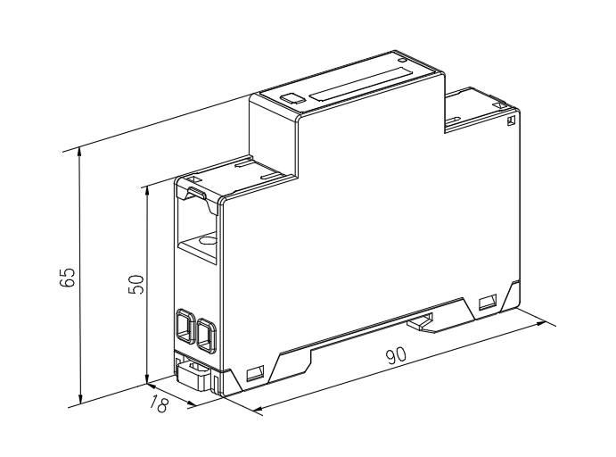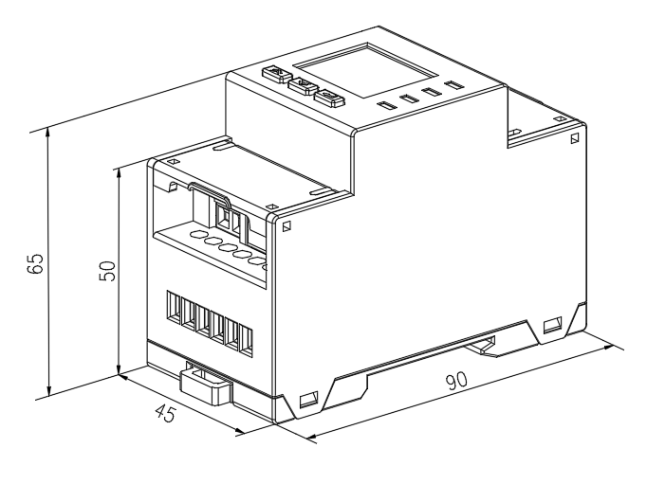
图1 ADL200N-CT  Figure 1 ADL200N-CT | 图2 ADL400N-CT  Figure 2 ADL400N-CT

6 接线与安装

6 Connection and Installation

6.1电压电流接线示意图

6.1 Schematic Diagram of Voltage and Current Connection
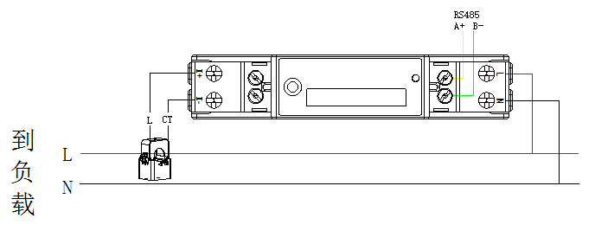
图3 ADL200N-CT
Figure 3 ADL200N-CT
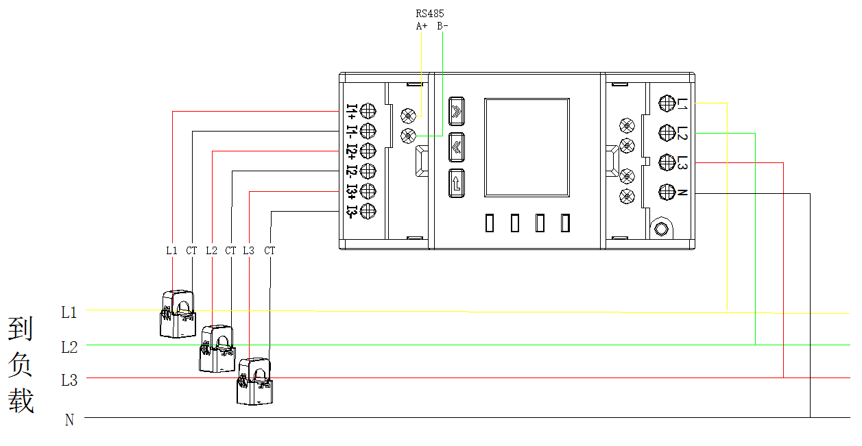
到负载
To load
图4 ADL400N-CT 三相四线经互感器接入
Figure 4 ADL400N-CT Three-phase Four-wire Connection Through Current Transformer
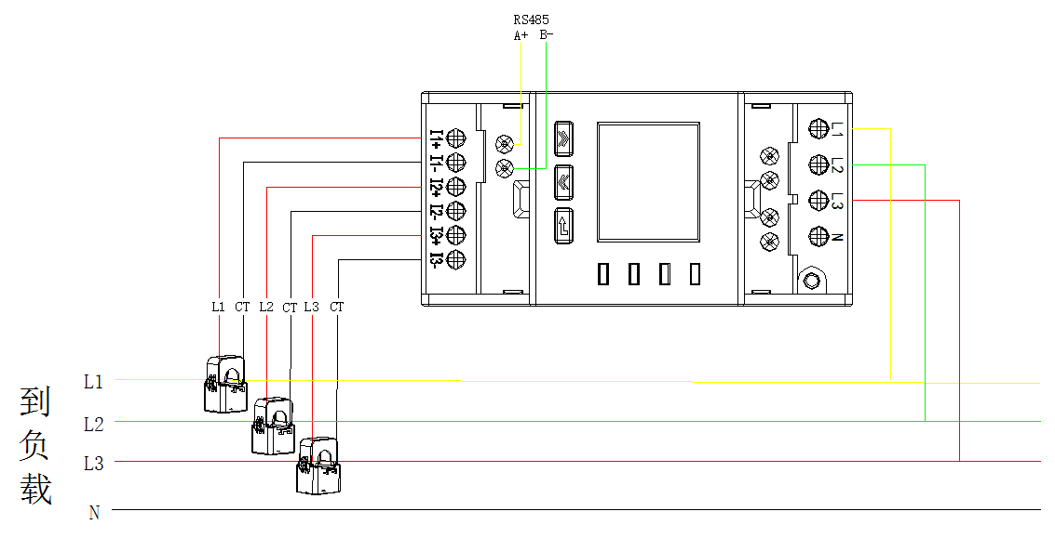
到负载
To load
图5 ADL400N-CT 三相三线经互感器接入（此接法仅限于三项平衡时）（仪表设置为3P4L）
Figure 5 ADL400N-CT Three-phase Three-wire Connection Through Current Transformer (this connection method is limited to three-phase balance) (instrument is set as 3P4L)

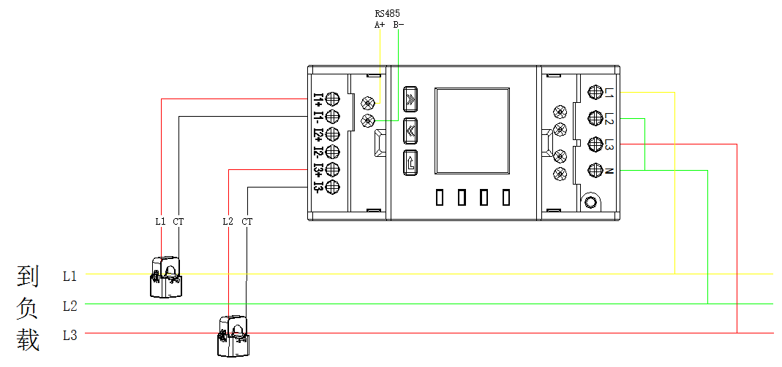
到负载
To load
图6 ADL400N-CT 三相三线经互感器接入（仪表设置为3P3L）
Figure 6 ADL400N-CT Three-phase Three-wire Connection Through Current Transformer (instrument is set as 3P3L)
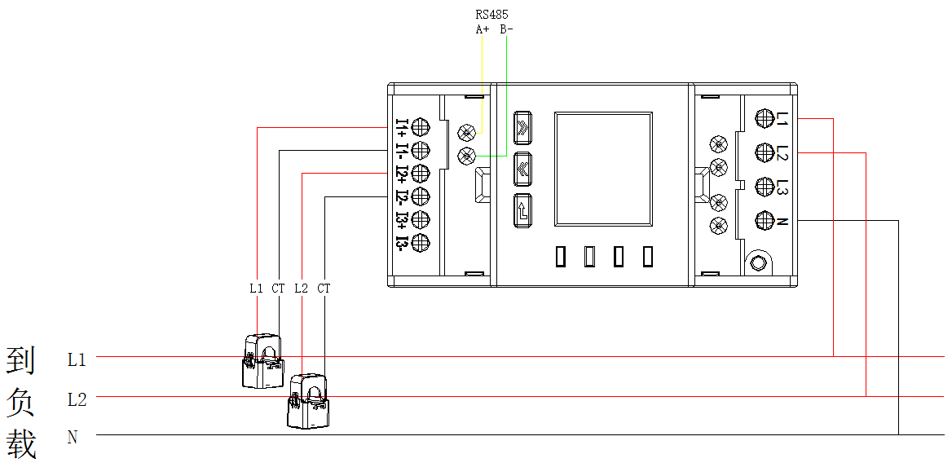
到负载
To load
图7 ADL400N-CT 单相三线经互感器接入
Figure 7 ADL400N-CT Single-phase Three-wire Connection Through Current Transformer

6.2 功能性端子

6.2 Functional Terminal
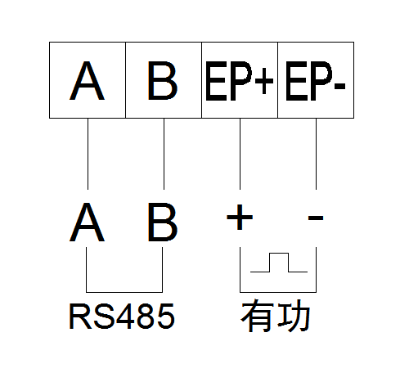
有功
Active
AB相电流Phase AB current
图8 通讯、脉冲接线
Figure 8 Communication and Pulse Connection

7 主要功能特点

7 Main Functional Features

7.1 测量功能

7.1 Measurement Function
能测量全电力参数包括电压U、电流I、有功功率P、无功功率Q、视在功率S、功率因数PF、频率。其中电压U保留1位小数，频率F保留2位小数，电流I保留2位小数，功率P保留3位小数。
It can measure total power parameters including voltage U, current I, active power P, reactive power Q, apparent power S, power factor PF and frequency. Wherein, the voltage U is reserved with 1 decimal place, the frequency F is reserved with 2 decimal places, the current I is reserved with 2 decimal places, and the power P is reserved with 3 decimal places.
如：U = 220.1V，f = 49.98Hz, I = 1.99A，P = 0.439kW
For example, U = 220.1V, f = 49.98Hz, I = 1.99A, P = 0.439kW
仪表同时提供以上电参量高速响应寄存器，见第9章通讯说明。
The above electrical parameter high-speed response registers are also provided with the instrument, see Chapter 9 “Communication Instructions”.

7.2计量功能

7.2 Metering Function
能计量当前组合有功电能，正向有功电能，反向有功电能，正向无功电能，反向无功电能。
It can measure the current combined active electric energy, forward active electric energy, reverse active electric energy, forward reactive electric energy and reverse reactive electric energy.

8操作与显示

8 Operation and Display

8.1按键功能说明

8.1 Key Function Description
表4 按键功能说明
Table 4 Key Function Description
按键图标  Key Icon | 按键名称  Key Name | 按键功能  Key Functions
 | 向上键  Up | 向左切换界面  编程界面中左移及闪烁移位  When switching the interface to the left, show left shift and flicker shift in programming interface
 | 向下键  Down | 向右切换界面  编程界面中右移及修改闪烁位  When switching the interface to the right, show right shift and modify flicker in programming interface
 | 编程确定键  Programming confirmation | 查看下级菜单  编程界面中确定保存设置  View submenu, confirm the saving setting in the programming interface

8.2显示界面

8.2 Display Interface
ADL200N：
可通过按键切换页面或自动循环显示页面
The interface can be switched by pressing the key or the interface can be displayed automatically and circularly

ADL400N：
图9 显示界面说明
Figure 9 Description of Display Interface

注：以上只是显示界面的一部分，A、B、C相可通过回车键切换（AB间、BC间、AC间同理），其他界面显示模式与上图类似，可根据界面中显示的信息来判断显示含义。
Note: The above is only a part of the display interface. Phase A, B and C can be switched by Enter key (phases between AB, BC and AC are for the same reason). The display mode of other interfaces is similar to that shown in the above figure. The display meaning can be judged according to the information displayed in the interface.

8.3编程界面

8.3 Programming Interface
在测量显示菜单中的任一显示项下，长按可进入“PASS”界面，提示输入密码，默认密码0001，再按，若密码输入错误，则返回“0000”可重新输入；若密码输入正确，则可进行参数设置。设置完成后长按进入“SAVE”界面，按键，切换为“YES”后按则保存并退出，在“no”下按则不保存直接退出。
When in any display item, press for a long time to enter the "PASS" interface. There is a prompt for password, and the default password is 0001, and then press again. If the password is incorrectly entered, return to "0000" to re-enter; If the password is entered correctly, the parameters can be set. Press for a long time to enter the "SAVE" interface, press to switch to "YES", then press to SAVE and exit, and press when switching to "NO" to exit directly, with no need to “SAVE”.
长按进入编程页面
Long press to enter the programming interface
通过输入密码
Enter the password by
点进入编程页面
Click to enter the programming interface
线制选择
Wire system selection
地址 脉冲常数设置
Address Pulse constant setting
波特率
Baud rate
检验选择
Inspection selection
背光设置时间
Backlight setting time
电流屏蔽值
Current shielding value
电压屏蔽值
Voltage shielding value
一次电流 Primary current
密码设置 Password setting
一次电压
Primary voltage
视在功率计算方式
Apparent power calculation mode
默认界面设置
Default interface settings
预留
Reserved
在设置完所有参数后，长按进入保存页面
After setting all parameters, long press to enter the save page
保存
Save
进入想要设置的页面按就可通过进行参数设置，设置完成后按确定。
Enter the page you want to set, and press to set the parameters through . After setting, press to confirm.

8.4可设置数据项

8.4 Settable Data Items
表7 设置菜单说明
Table 7 Description of Setting Menu
符号Symbol | 含义Meaning | 范围Scope
Addr | 通讯地址设置slave address | 1-247
bAud | 波特率选择  Baud rate | 38.4：38400  19.2：19200  9.6：9600  4.8：4800  2.4：2400  1.2：1200
PAri | 校验选择parity | None、Even、Odd
LEd | 背光时间（预留）  Backlight time (reserved) | 0-999s
PL | 网络选择  Grid | 3P4L:三相四线  3P4L: Three-phase four-wire  3P3L:三相三线  3P3L: Three-phase three-wire
UPri | 一次电压Primary voltage | 0.1-9999999.9V
iPri | 一次电流Primary current | 0.01-999999. 99A
UMSK | 电压屏蔽值Voltage shielding value | 0-99.99%
iMSK | 电流屏蔽值Current shielding value | 0-99.99%
PULS | 脉冲常数Pulse constant | 1-99999
S-ty | 视在功率计算方式  Apparent power calculation mode | RMS：RMS计算法  RMS: RMS calculation method  PQS：PQS计算法  PQS: PQS calculation method
diSP | 上电默认界面  Power-on default interface | Auto：自动轮显  Auto: Automatic wheel display  其他：其他界面  Others: Other interfaces
PHSq | 预留Reserved
CoDE | 密码设置Password | 1-9999

9 通信说明

9 Communication Instructions
仪表RS485通信接口支持MODBUS-RTU通信协议，通信口波特率可在1200bps、2400 bps、4800 bps、9600bps、19200 bps和38400 bps之间设置，校验位为无校验。
The instrument RS485 communication interface supports MODBUS-RTU communication protocol. The baud rate of communication interface can be set between 1,200bps, 2,400 bps, 4,800 bps, 9,600bps, 19,200 bps and 38,400 bps, and the check bit is no check.
仪表的RS485通信口要求使用屏蔽双绞线连接，布线时要考虑整个网络的布局：如通信线缆的长度、走向、上位机的位置、网络末端的匹配电阻、通信转换器、网络可扩展性、网络覆盖范围、环境的电磁干扰情况等因素，都要综合考虑。
The RS485 communication interface of the instrument requires shielded twisted pair connection, and the layout of the whole grid should be considered when wiring: For example, the length and direction of communication cable, the position of upper computer, the matching resistance at the end of the grid, the communication converter, the scalability of the grid, the coverage of the grid, the electromagnetic interference of the environment and other factors should be considered comprehensively.
注：
Note:
1、在布线工程上要严格按要求施工；
1. It shall strictly construct according to the requirements in the wiring project;
2、对于暂时不需要通信的仪表都要将他们连接到RS-485网络上，以便于诊断和测试；
2. For instruments that do not need communication temporarily, they should be connected to RS-485 grid for diagnosis and test;
3、进行RS-485电缆连接时，尽量使用双色双绞线，所有的485通信口“A”端接同一种颜色，“B”端接另一种颜色。
3. When connecting RS-485 cable, try to use two-color twisted pair. All 485 communication ports "A" are terminated in the same color, and "B" is terminated in another color.
4、RS-485总线(从上位机通信口开始到任一被连接的仪表终端通信口)长不超过1000米。
4. The length of RS-485 bus (from the communication interface of the upper computer to any connected instrument terminal communication interface) shall not exceed 1,000 meters.

9.1 地址表

9.1 Address Table
仪表支持MODBUS-RTU协议中的03H命令与10H命令，03H为读多个寄存器，10H为写多个寄存器，协议数据格式请自行查询。下表为仪表的寄存器地址表：
Meter supports 03H command and 10H command in MODBUS-RTU protocol, in which 03H for reading multiple registers and 10H for writing multiple registers. Please check the protocol data format by yourself. The following table is the register address table of the meter:
表8 通讯地址表
Table 8 Communication Address Table
地址  Address | 名称Name | R/W | 字长  Length  (Bytes) | 类型  Type | 单位  Unit | 备注Note
1000H | 地址slave address | R/W | 1 | uint16 |  | 1-247
1001H | 波特率  baud rate | R/W | 1 | uint16 |  | 1200，2400，4800，9600，19200，38400，
 | 校验位  parity | R/W | 1 | uint16 |  | 低字节  0：无校验None  1：奇校验Odd  2：偶校验Even  高字节  0：1停止位 1stop  1：1.5停止位 1.5stop  2：2停止位 2stop
1010H | 网络选择Grid | R/W | 1 | uint16 |  | 0:3P4L 1:3P3L
1011H | 电压二次额定值  rated second voltage | R/W | 1 | uint16 | 0.1V | 0.1-999. 9V
1012H | 电流二次额定值  rated second current | R/W | 1 | uint16 | 0.01A | 0.01-999. 99A
1015H | 电压一次额定值  rated primary voltage | R/W | 1 | uint32 | 0.1V | 0.1-99999.9V
1017H | 电流一次额定值  rated primary current | R/W | 1 | uint32 | 0.01A | 0.01-9999. 99A
101DH | 密码Password | R/W | 1 | uint16 |  | 1-9999
101EH | 脉冲常数Pulse constant | R/W | 1 | uint16 |  | 1-99999
101FH | 电压屏蔽Voltage shielding value | R/W | 1 | uint16 | 0.01%
1020H | 电流屏蔽Current shielding value | R/W | 1 | uint16 | 0.01%
1023H | 上电默认界面  Power-on default interface | R/W | 1 | uint16 |  | 0：自动轮显  0: Automatic wheel display  其他：其他界面  Others: Other interfaces
1035H | 视在功率计算方式  Apparent power calculation mode | R/W | 1 | uint16 |  | 0：RMS 1：PQS
2000H | A相电压A-phase voltage | R | 2 | float | V | 1.慢速寄存器  1.Slow register  2.ADL200N只有A相数据  2.ADL200N only has A-phase data
2002H | B相电压B-phase voltage | R | 2 | float | V
2004H | C相电压C-phase voltage | R | 2 | float | V
2006H | AB线电压AB-line voltage | R | 2 | float | V
2008H | BC线电压BC-line voltage | R | 2 | float | V
200AH | CA线电压CA-line voltage | R | 2 | float | V
200CH | A相电流A-phase current | R | 2 | float | A
200EH | B相电流B-phase current | R | 2 | float | A
2010H | C相电流C-phase current | R | 2 | float | A
2012H | N线电流N-phase current | R | 2 | float | A
2014H | A相有功功率  A-phase active power | R | 2 | float | kW
2016H | B相有功功率  B-phase active power | R | 2 | float | kW
2018H | C相有功功率  C-phase active power | R | 2 | float | kW
201AH | 总有功功率  Total active power | R | 2 | float | kW
201CH | A相无功功率  A-phase reactive power | R | 2 | float | Kvar
201EH | B相无功功率  B-phase reactive power | R | 2 | float | Kvar
2020H | C相无功功率  C-phase reactive power | R | 2 | float | Kvar
2022H | 总无功功率total reactive power | R | 2 | float | Kvar
2024H | A相视在功率  A-phase apparent power | R | 2 | float | KVA
2026H | B相视在功率  B-phase apparent power | R | 2 | float | KVA
2028H | C相视在功率  C-phase apparent power | R | 2 | float | KVA
202AH | 总视在功率Total apparent power | R | 2 | float | KVA
202CH | A相功率因数  A-phase power factor | R | 2 | float
202EH | B相功率因数  B-phase power factor | R | 2 | float
2030H | C相功率因数  C-phase power factor | R | 2 | float
2032H | 总功率因数Total power factor | R | 2 | float
2034H | 频率Frequency | R | 2 | float | Hz
2100H | A相电压A-phase voltage | R | 2 | float | V | 1.快速寄存器  （响应时间<=100ms）  1.Slow register  （response rate <=100ms）  2.ADL200N只有A相数据  2.ADL200N only has A-phase data
2102H | B相电压B-phase voltage | R | 2 | float | V
2104H | C相电压C-phase voltage | R | 2 | float | V
2106H | AB线电压AB-line voltage | R | 2 | float | V
2108H | BC线电压BC-line voltage | R | 2 | float | V
210AH | CA线电压CA-line voltage | R | 2 | float | V
210CH | A相电流A-phase current | R | 2 | float | A
210EH | B相电流B-phase current | R | 2 | float | A
2110H | C相电流C-phase current | R | 2 | float | A
2112H | N线电流N-phase current | R | 2 | float | A
2114H | A相有功功率  A-phase active power | R | 2 | float | kW
2116H | B相有功功率  B-phase active power | R | 2 | float | kW
2118H | C相有功功率  C-phase active power | R | 2 | float | kW
211AH | 总有功功率Total active power | R | 2 | float | kW
211CH | A相无功功率  A-phase reactive power | R | 2 | float | Kvar
211EH | B相无功功率  B-phase reactive power | R | 2 | float | Kvar
2120H | C相无功功率  C-phase reactive power | R | 2 | float | Kvar
2122H | 总无功功率total reactive power | R | 2 | float | Kvar
2124H | A相视在功率  A-phase apparent power | R | 2 | float | KVA
2126H | B相视在功率  B-phase apparent power | R | 2 | float | KVA
2128H | C相视在功率  C-phase apparent power | R | 2 | float | KVA
212AH | 总视在功率Total apparent power | R | 2 | float | KVA
212CH | A相功率因数  A-phase power factor | R | 2 | float
212EH | B相功率因数  B-phase power factor | R | 2 | float
2130H | C相功率因数  C-phase power factor | R | 2 | float
2132H | 总功率因数Total power factor | R | 2 | float
2134H | 频率Frequency | R | 2 | float | Hz
3000H | 总有功电能一次值  active electric energy | R | 4 | double | kWh
3004H | 正向有功电能一次值  forward active electric energy | R | 4 | double | kWh
3008H | 反向电能一次值  reverse active electric energy | R | 4 | double | kWh
300CH | 总无功电能一次值  reactive electric energy | R | 4 | double | kVarh
3010H | 正向无功电能一次值  forward reactive electric energy | R | 4 | double | kVarh
3014H | 反向无功电能一次值  reverse reactive electric energy | R | 4 | double | kVarh
3018H | 视在电能一次值  apparent electric energy | R | 4 | double | kVAh
301CH | A相总有功电能一次值  active electric energy of phase A | R | 4 | double | kWh
3020H | A相正向有功电能一次值  forward active electric energy of phase A | R | 4 | double | kWh
3024H | A相反向有功电能一次值  reverse active electric energy of phase A | R | 4 | double | kWh
3028H | A相无功电能一次值  reactive electric energy of phase A | R | 4 | double | kVarh
302CH | A相正向无功电能一次值  forward reactive electric energy of phase A | R | 4 | double | kVarh
3030H | A相反向无功电能一次值  reverse reactive electric energy of phase A | R | 4 | double | kVarh
3034H | B相总有功电能一次值  active electric energy of phase B | R | 4 | double | kWh
3038H | B相正向有功电能一次值  forward active electric energy of phase B | R | 4 | double | kWh
303CH | B相反向有功电能一次值  reverse active electric energy of phase B | R | 4 | double | kWh
3040H | B相无功电能一次值  reactive electric energy of phase B | R | 4 | double | kVarh
3044H | B相正向无功电能一次值  forward reactive electric energy of phase B | R | 4 | double | kVarh
3048H | B相反向无功电能一次值  reverse reactive electric energy of phase B | R | 4 | double | kVarh
304CH | C相总有功电能一次值  active electric energy of phase C | R | 4 | double | kWh
3050H | C相正向有功电能一次值  forward active electric energy of phase C | R | 4 | double | kWh
3054H | C相反向有功电能一次值  reverse active electric energy of phase C | R | 4 | double | kWh
3058H | C相无功电能一次值  reactive electric energy of phase C | R | 4 | double | kVarh
305CH | C相正向无功电能一次值  forward reactive electric energy of phase C | R | 4 | double | kVarh
3060H | C相反向无功电能一次值  reverse reactive electric energy of phase C | R | 4 | double | kVarh

Contact person: Augustus Yang
Foreign Business Dpt.
Acrel Co., Ltd.
Mobile/Wechat/ WhatsApp: (+86) 136 1197 6994
Skype: rayyang11081
Email: augustus@acrel.cn
Website: www.acrel.sg Headquarters: No. 253, Yulv Road, Jiading Zone, Shanghai, China
Factory: No. 5 Dongmen Road, Nanzha Street, Jiangyin, Jiangsu, China

