**Annex 1**



# ACCU-100 Microgrid Coordination Controller

## Technical specification book

**Acrel Electric Co., Ltd.**

目录

directory 2

1. Product Introduction 3

2.Features 3

3.Product Parameters 5

4.System Architecture 7

5.Technical Standards 7

6.Performance Indicators 8

7.Energy Scheduling 9

8.Device wiring 10

9.Dimensions 11

10.General requirements 12

11.Technical Services 12

1. **Product Introduction**

ACCU-100 Microgrid Coordination Controller is an intelligent coordination controller used in microgrid,distributed generation,energy storage and other fields.The device meets the requirements of the system to meet the access of photovoltaic systems,wind power generation,energy storage systems,charging piles and other equipment.Through all-weather data collection and analysis of the microgrid system,the operation status of photovoltaic,wind energy, energy storage system and charging piles is monitored.The health status of the microgrid is analyzed,and on this basis,the optimal control strategy is obtained with the goal of safe and economical optimal operation,and then the microgrid is implementedRegulation and control to achieve real-time dynamic regulation of microgrid distributed energy,energy storage system,and load,and promote local use of new energy.Improve grid operation stability and compensate for load fluctuations;effectively manage microgrid demand and improve microgrid operation.Improve operation efficiency,reduce power supply costs,and ensure safe,reliable and economical operation of microgrids.

**2.Features**

ACCU-100 microgrid coordination controller has the following features:

Data collection:support multi-channel real-time operation such as serial port and Ethernet,and meet the access of various wind power and photovoltaic inverters,energy storage and other equipment;

Communication management:Support Modbus RTU,Modbus TCP, IEC 60870-5-101,IEC 60870-5-103,IEC60870-5-104, MQTT and other communication protocols,which can realize cloud-edge collaboration (combined with Acrel Smart Energy Management Cloud Platform for remote operation and maintenance),OTA upgrade,local/remote switching,local human-computer interaction(optional);

Edge computing:flexible alarm threshold settings,active upload of alarm information,data merging and calculation, logic control,breakpoints resume,data encryption, 4G routing;

Strategy management:anti-backflow,planning curve,peak shaving and valley filling,demand control,active/reactive power control,solar-storage coordination,etc.And support strategy customization;

System security:user permissions designed based on untrusted models to prevent illegal users from intruding;Security verification technology uses data calibration and anti-tampering mechanisms to achieve data authentication and traceability;

Operational safety:Collect and analyze the entire station’s signals and measurement data,including battery,temperature control,and fire protection,to achieve operational safety early warning and forecast.

**3.Product Parameters**

**ACCU-100 microgrid controller is mainly responsible for data collection and local control strategy of industrial and commercial photovoltaic storage and charging new energy power stations.And the interaction of cloud data.Supported capacity: energy storage capacity:≤400kW,photovoltaic capacity:≤400kWp.**

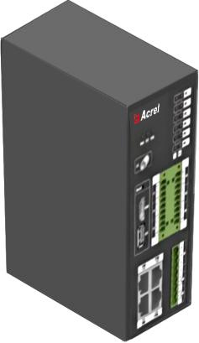

**Figure 3-1 ACCU-100 product diagram**

**The typical hardware configuration and accessory parameters of the ACCU-100 microgrid controller are shown in Table 3-1.**

|  |  |  |
| --- | --- | --- |
|  | **Table 3-1 Typical configuration parameters** |  |
|  |  |  |
| **project** | **Specification** |  |
| **processor** | **ARM Cortex-A7 528MHz** |  |
| **Memory** | **256MB DDR3 + 256MB NAND Flash** |  |
| **Frequency and power consumption** | **50Hz (45〜65Hz), power consumption ≤10W** |  |
| **Supply voltage** | **AC/DC 220V (85-265V)** |  |
| **RS485 Serial Port** | **8-way optocoupler isolation** |  |
| **RJ45Network port** | **2-way 10/100M adaptive** |  |
| **Other interfaces** | **1*RS232 management serial port + 1*USB2.0 + SD Card standard slot + 4G interface; (DI, DO optional)** |  |
| **Protocol support** | **Device side: Modbus Rtu/TCP, DL/T 645-1997, DL/T 645, etc.;** |  |
| **Master side: Modbus TCP, 104, SNMP, MQTT protocol, etc.;** |  |
|  |  |
| **Security** | **Power frequency withstand voltage: 1 minute between power supply and communication terminals: 2kV (220V equipment), 1.5kV (24V equipment)** |  |
| **Insulation resistance: Under normal test atmospheric conditions, the input and output terminals to the housing> 100MΩ** |  |
|  |  |
|  | **Working temperature: -20℃〜+55℃** |  |
| **environment** | **Storage and transportation temperature: -25℃〜+70℃** |  |
| **Relative humidity: ≤95% (+25℃)** |  |
|  |  |
|  | **Altitude: ≤2500m** |  |
|  | **GB/T 17626.2-2018 Electrostatic discharge immunity test Level 4** |  |
| **Electrical properties** | **GB/T 17626.3-2016 Radio frequency electromagnetic field radiation immunity test Level 3** |  |
| **GB/T 17626.4-2018 Electrical fast transient burst immunity test Level 4** |  |
|  |  |
|  | **GB/T 17626.5-2019 Surge (impact) immunity test Level 4** |  |

**4.System Architecture**

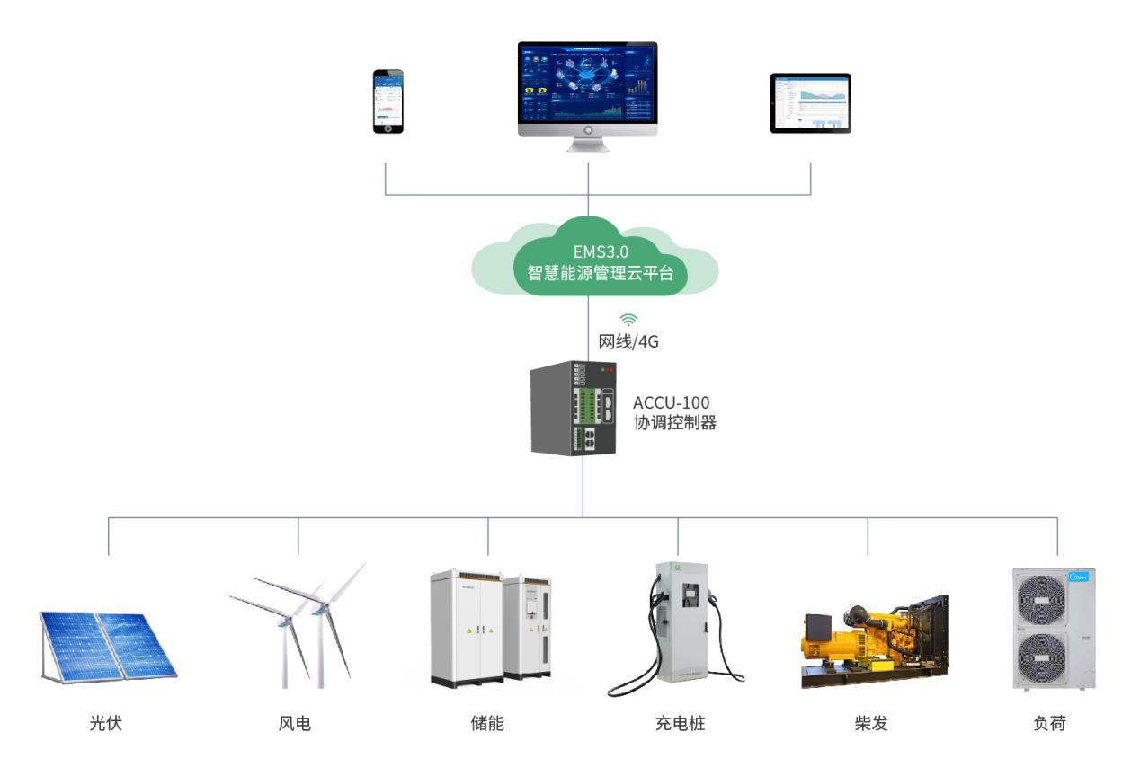

**Figure 4-1 System architecture**

**ACCU-100Coordination controller:Control the output of energy storage equipment,distributed energy,and adjustable load equipment.According to the economic benefit model,the photovoltaic storage replacement can be carried out under the premise of meeting the dispatching requirements,reducing abandoned light.And interact with the cloud platform and respond to cloud policy configuration.**

**EMS3.0,a smart energy management cloud platform,meets the access of cross-site and cross-regional massive data,realizes the calculation and control of resources,electricity,loss,indicators,maintenance,and contribution indicators of each site through data analysis,and analyzes the trend of power generation and consumption through diversified forecasting,and provides the best control scheme in combination with electricity price data,production plan,and load demand.At the same time,it provides remote monitoring and operation and maintenance functions.**

**5.Technical Standards**

**The main standards of the products are as follows:**

* **GB/T 13729-2002 Telecontrol terminal equipment**
* **GB/T 17626.4 Electromagnetic compatibility test and measurement technology Electrical fast transient burst immunity test**
* **GB/T 15153.1 Telecontrol equipment and systems – Part 2: Operating conditions – Part 1: Power supply and electromagnetic compatibility compatibility**
* **GB/T 15153.2 Telecontrol equipment and systems Part 2: Working conditions Part 2: Environmental conditions (climate, machinery and Other non-electrical factors)**
* **B/T 4208-2008 Enclosure protection rating (IP code)**
* **Q/GDW 639-2011 Inspection procedures for distribution automation terminal equipment**
* **NB/T 32015 Technical regulations for distributed power generation access to distribution networks**
* **DL/T 584 3~110kV power grid relay protection device operation setting regulations**
* **DL/T 721-2013 Distribution Network Automation Remote Terminal**
* **DL/T 630-1997 AC sampling telecontrol terminal technical specifications**
* **DB/T 864-2012 Technical specification for microgrid access to distribution network of 10kV and below**
* **GB/T 33589-2017 Technical regulations for microgrid access to power system**
* **GB/T 36274-2018 Technical specification for microgrid energy management system**
* **GB/T 36270-2018 Technical specification for microgrid monitoring system**
* **DL/T 1864-2018 Technical specification for stand-alone microgrid monitoring system**
* **T/CEC 153-2018 Technical Guidelines for Load Management of Grid-Connected Microgrids**
* **T/CEC 152-2018 Technical requirements for demand response of grid-connected microgrids**
* **T/CEC 153-2018 Technical Guidelines for Load Management of Grid-Connected Microgrids**

**6.Performance Indicators**

**Table 6-1 ACCU-100 coordination controller performance indicators**

|  |  |
| --- | --- |
| **Technical indicators project** | **index** |
| **Telemetry response time** | **≤10s** |
| **Telemetry comprehensive error rate** | **≥99.9%** |
| **Remote signal change response time** | **≤2s** |
| **Remote signal accuracy** | **≥99.9%** |
| **Remote control command response time** | **≤5s** |
| **Remote control accuracy** | **≥99.9%** |
| **System availability** | **≥99.9%** |
| **Timing accuracy** | **≤1S** |
| **Data recording time stamp accuracy** | **≤1ms** |
| **Number of status variables supported by the system** | **≤30000** |
| **Number of analog quantities supported by the system** | **≤30000** |
| **The number of control quantities supported by the system** | **≤30000** |
| **Protocol support** | **IEC 104/Modbus/MQTT/HTTP** |

**7.Energy Scheduling**

|  |  |  |
| --- | --- | --- |
|  | **Table 7-1 Typical energy scheduling function table** |  |
|  |  |  |
| **Operation Mode** | **Control Logic** |  |
|  |  |  |
| **Manual Strategy** | **Supports manual switching of microgrids on and off the grid,distributed generation, energy storage, adjustable equipment instructions,remote control,etc.** |  |
| **Planning Curve** | **Users can configure the electricity price template based on the local time-of-use electricity price, set the charging and discharging power of energy storage in different time periods, and form a peak-shaving and valley-filling strategy template; it provides the function of configuring strategy templates by day and week, and adapts to the strategy operation mode in multiple regions and multiple electricity price environments.** |  |
|  |
|  |  |
|  |  |
| **Demand Control** | **The demand value is collected in real time by connecting the main meter to the low-voltage side of the transformer of the main incoming line. When the demand value reaches the limit value (which can be set), the demand control is triggered. The system reduces the charging and discharging of the energy storage, reduces the charging power of the charging pile, or reduces the power consumption of the adjustable load according to the configured parameters.** |  |
|  |
|  |
|  |
|  | **The transformer load rate is collected in real time by connecting a main meter to the low-voltage side of the transformer in the main incoming line. When the transformer load rate reaches the limit value (settable),the protection is triggered.The system reduces charging and discharging of the energy storage, reduces the charging power of the charging pile, or reduces the power consumption of the adjustable load according to the configured parameters.** |  |
| **Dynamic expansion** |  |
|  |  |
|  |  |
| **New energy consumption** | **By connecting the main meter on the low-voltage side of the transformer of the main incoming line to collect reverse power data in real time,when reverse power occurs and reaches the limit value (which can be set), when the system detects reverse flow, it will give priority to dispatching the energy storage system to absorb excess photovoltaic energy;when the energy storage system is full, the output power of the photovoltaic inverter will be adjusted (if there is a reverse flow protection requirement).** |  |
|  |
|  |
|  |
|  |
| **Anti-backflow control system** | **By connecting the main meter on the low-voltage side of the transformer of the main incoming line to collect reverse power data in real time, when reverse power occurs and reaches the limit value** |  |
| **(which can be set), the system will take actions such as static storage, reduced discharge, charging, or photovoltaic power reduction according to the configured parameters. The system's anti-reverse** |  |
| **flow strategy is implemented as software protection. If you need to achieve faster response and more reliable protection, you need to add a corresponding reverse power protection device, and** |  |
| **immediately trip the protection when reverse flow is detected.** |  |
|  |  |
| **Backup power function** | **During system operation, the EMS coordinates control and executes SOC protection for the energy storage system, allowing the energy storage system to operate within the set SOC range and reserve a certain power interval for backup capacity. The backup capacity can be customized and can provide emergency power to the load when the grid is out of power.** |  |
|  |
|  |
|  |
| **other** | **Different strategies can be customized according to customer needs** |  |
|  |

**8.Device wiring**

**ACCU-100 coordination controller adopts standard rail installation.After the device is plugged into the network cable,the green LINK light will light up,flashes when there is data,the yellow SPEED light is always on at 100Mb/s and off at 10Mb/s;the device is transmitting or receiving dataThe data RX red light flashes,and the data sending TX green light flashes.**

**Both the rear plate and the bottom plate can be installed with guide rail holders****.**

**9.Dimensions**

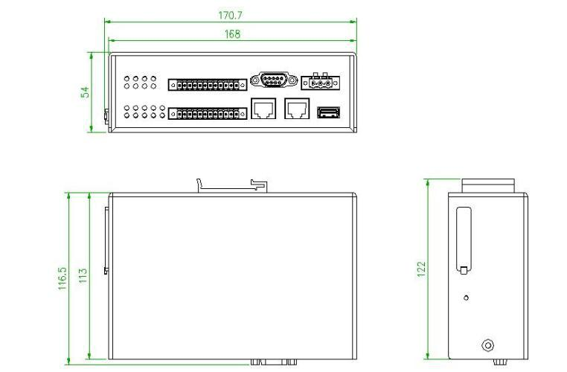

**Figure 9-1 Device dimensions**

**10.General requirements**

**10.1.General requirements**

**Take measures such as shielding and corresponding anti-interference to prevent equipment damage caused by electromagnetic interference and lightning interference,and ensure that the device can operate safely and effectively under the specified environmental conditions.**

**10.2.Packaging and transportation**

1. **The packaging of the equipment should comply with the relevant regulations, and take measures such as rainproof, moisture-proof, rust-proof, shock-proof, etc., so as to avoid damage caused by vibration and collision during transportation.**
2. **Consider the support and fixation of the equipment in the packing box,and pack all loose parts separately and put them in the box.**
3. **Each package should have a packing list that corresponds to the package, place it in a conspicuous position on the package, and pack it in a moisture-proof sealed bag. The parts contained in the bag should be clearly marked or labeled, at least indicating the part number, number, name, quantity,etc.and the relevant information should be consistent with the packing list.**
4. **Equipment and accessories should be protected from moisture and corrosion to ensure that they will not rust or be damaged within 12 months.After 12 months, it should be inspected and re-treated with rust prevention.**
5. **The package should comply with the provisions of the transportation operation,and avoid the sliding, impact and friction of the parts in the package during transportation and loading and unloading, resulting in damage to the parts.**

**11.Technical Services**

1. **Provide the buyer with all technical information specified in the contract in a timely manner.**
2. **Promptly guide the buyer to carry out installation,partial and complete trial operation and trial production in accordance with the supplier's technical data and drawings.**
3. **Arrange business training on equipment installation,commissioning,use and maintenance technology for the buyer in accordance with the contract.**
4. **Strictly implement the minutes of meetings or agreements signed between the buyer and seller on major issues.**
5. **Provide good pre-sales,sales and after-sales services.**
6. **Meet the buyer’s requirements for spare parts at any time.**